Acceptance Testing
UAT Execution & Report Submission
Date | 25-06-2026
Team ID | 23A51A4441
Project Name | Metro Ticket Generating System in ServiceNow
Maximum Marks | 4 Marks

- Purpose of Document
The purpose of this document is to briefly explain the test coverage and open issues of the Metro Ticket Generating System in ServiceNow project at the time of the release to User Acceptance Testing (UAT).
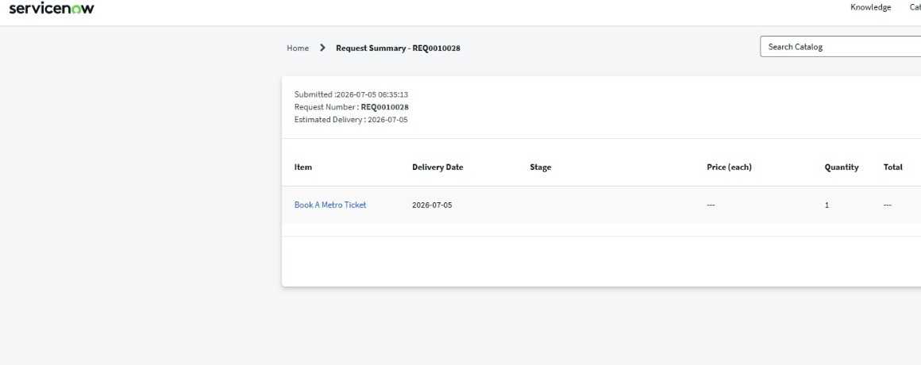
Fig: Request Summary confirming successful Metro Ticket booking (REQ0010028)

- Defect Analysis
Resolution | Severity - 1 | Severity - 2 | Severity - 3 | Severity - 4 | Subtotal
Fixed | 2 | 4 | 5 | 6 | 17
By Design | 0 | 1 | 2 | 2 | 5
Duplicate | 0 | 0 | 1 | 1 | 2
Not  Reproduced | 0 | 1 | 1 | 0 | 2
Skipped | 0 | 0 | 1 | 0 | 1
Won't Fix | 0 | 0 | 0 | 1 | 1
Totals | 2 | 6 | 10 | 10

- Testcase Analysis : This report shows the number of test cases that have passed, failed, and untested
Section | Total Cases | Not Tested | Fail | Pass | Section
Metro Ticket Booking Form | 8 | 0 | 0 | 8 | Metro Ticket Booking Form
Fare Calculation | 10 | 0 | 1 | 9 | Fare Calculation
Station Selection  Validation | 6 | 0 | 0 | 6 | Station Selection Validation
GlideAjax & Script Include  Integration | 5 | 0 | 0 | 5 | GlideAjax & Script Include Integration
Ticket Generation  (REQ/RITM) | 8 | 0 | 0 | 8 | Ticket Generation (REQ/RITM)
Email Notifications | 5 | 0 | 1 | 4 | Email Notifications
QR Code Generation | 4 | 0 | 0 | 4 | QR Code Generation
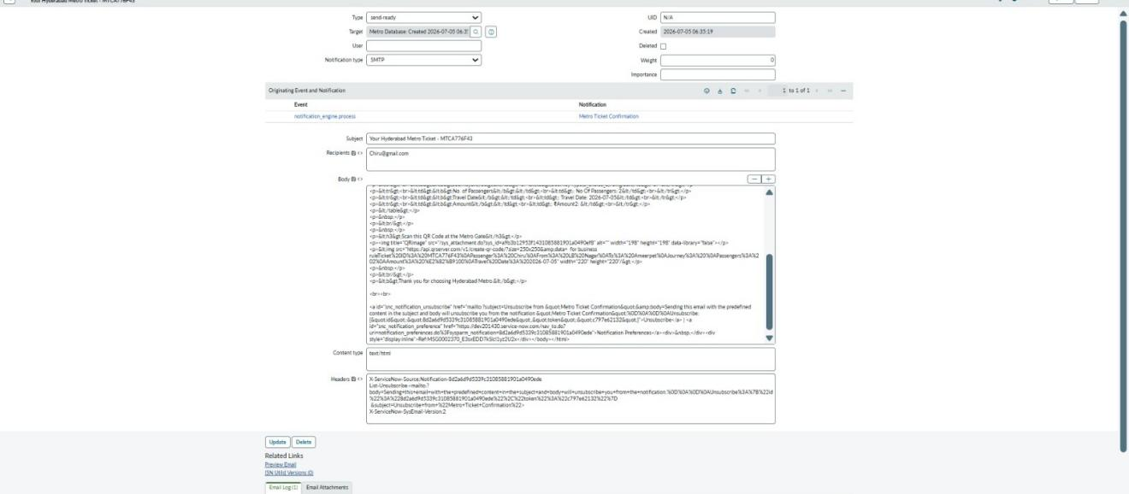
Fig: Email Notification sent to the passenger upon ticket confirmation

